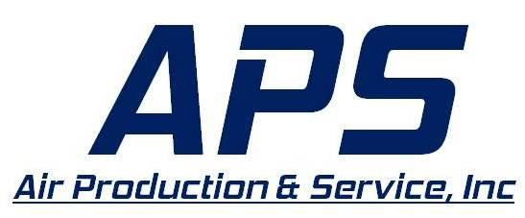

Position: Air Compressor Technician
Essential Job Functions:
Service Maintenance and Repair
The Service Technician will perform routine, preventative maintenance and repairs on rotary screw air compressors. Preventative maintenance should be conducted in accordance with manufacturer’s recommendations. The main responsibility of this role is to troubleshoot and perform diagnostics on malfunctioning compressors, determine possible causes for malfunctions, and perform repairs. Prior to and following preventative maintenance and repairs, they are responsible to test and document the proper operating parameters of the compressor.
Customer Service
The Service Technician must provide a high level of customer service, responding to customer needs and working to satisfy customer expectations within a timely manner. A good Service Technician can guarantee returned business by developing rapport with customers through effective communication, interpersonal skills, and professionalism.
Qualifications
- High School diploma or equivalent required with technical training in electrical, hydraulics, and/or pneumatics preferred.
- 1-2 years of strong mechanical and electrical skills with demonstrated expertise in the maintenance, overhaul, and repair of a wide variety of industrial equipment, including electrical, hydraulics and/or pneumatics.
- Compressor experience strongly desired.
- HVAC and Control experience a plus, but not required.
- Possess and maintain a valid Driver s License.
- Able to work independently with strong self-management and professionalism.
- Able to complete work within assigned deadlines.
- Computer proficiency as required for communication, research, work orders and programming various controllers.
- Ability to use Microsoft Word and Excel for report purposes
- Wear protective equipment (such as hard hat, steel toe shoes, safety glasses and hearing protection)
- Work outside in all weather conditions
- Work hours may vary in length and schedule (may include a non-standard work week)
- Available for a rotating schedule of on-call work on evenings, weekends and holidays.
- Travel and overnight stays will be required.
- Must be able to lift up to 50 lbs. on a regular basis and work in industrial environments including extremes in temperature with continuous walking, reaching, bending, and kneeling.
- The applicant selected for this position may be required to successfully complete a background check and drug test.

Additional Job Functions
Please note this job description is not designed to cover or contain a comprehensive listing of activities, duties or responsibilities that are required of the employee for this job. Duties, responsibilities and activities may change at any time with or without notice
- Become familiar with multiple functions of in-house business & service software system.
- Additional duties as assigned

Additional Eligibility Qualifications
- Must possess or be able to obtain a valid and appropriate state driver’s license prior to employment.
- Must pass a pre-employment drug screening and random drug screenings when selected.
- Must pass pre-employment background check.

Benefits:
- 2-week paid time off after 6 months of continuous employment
- 8 paid holidays
- Company paid Health Insurance – Employee and Family
- Health Savings Account contributions
- Company negotiated – Eye, Dental, Life and Disability insurances
- 401K matching up to 5%
- Boot allowance after 6 months of continuous employment
- Prescription safety glasses allowance after 6 months of continuous employment

Job Type
- This is a full-time position which will typically involve 50+ hours a week. Due to the nature of the job, the employee must be available on-call early/late hours to deal with delays, bad weather and emergencies at the job site. This may include non-standard work weeks.

Travel
- Weekly travel is to be expected.

Locations: Baltimore Area

Air Production & Service is a dedicated service group to the railroad industry providing facility solutions and maintenance support to operations within the railroad industry.

EEO Statement
Air Production & Service Inc. provides equal employment opportunities (EEO) to all employees and applicants for employment without regard to race, color, religion, sex, national origin, age, disability or genetics. In addition to federal law requirements, Air Production & Service Inc. complies with applicable state and local laws governing nondiscrimination in employment in every location in which the company has facilities. This policy applies to all terms and conditions of employment, including recruiting, hiring, placement, promotion, termination, layoff, recall, transfer, leaves of absence, compensation and training.

